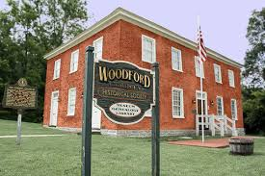
Woodford County Historical Society
121 Rose Hill Avenue
Versailles, KY 40383
859-873-6786
Preserving the Past, for Future generations!
Please print and complete form. Either “Drop by” or Mail in

Regular Membership

__ Adult $ 25
__ Family $ 40
__ Friend $ 65
__ Supporter $ 100
__ Benefactor $500 __ a very generous donation $ _____

Please make checks payable to Woodford County Historical Society. We are a 501 (c) 3, non-profit and your gift may be tax deductible. (Please consult your tax preparer for more information). We thank you in advance for your kind gift.

Name: _______________________________________________________________________
Email: _______________________________________________________________________
Address: _______________________________City:__________________State:___ Zip:______

How would you like to receive your Quarterly Newsletter, “Woodford Heritage News”?
____ Electronically, by email _____ hardcopy, by USPS

Thank you for your Support!!!

